Faculty of Information Technology (FIT) – Ho Chi Minh City University of Science (HCMUS)
CS423 / CSC13003 – Software Testing (AI-augmented · 2026)
AI POLICY · TEMPLATES — 2026 v1.0

Privacy & Responsible AI Use Checklist
Run through this checklist before submitting any AI-assisted work.
Adapted from Med Kharbach, PhD (2026) — AI Use Policy Templates for Higher Education. CC BY-NC-SA 4.0. This adaptation is prepared for FIT@HCMUS – CS423 / CSC13003 Software Testing course.

1. Before I use AI
- [x] I confirmed the AI Use Category assigned to this assignment.
- [x] I have declared which AI tool(s) I will use in my prompt log.
- [x] I have read the AI Use Agreement for this course.
- [x] I understand which artifacts MUST NOT be AI-generated.

2. While I am using AI
- [x] I did not enter personal data of classmates, customers, or patients.
- [x] I did not paste copyrighted reading materials wholesale into the AI.
- [x] I did not paste proprietary employer or open-source license-restricted code.
- [x] I logged each prompt + AI response into prompt_log.md with timestamp.

3. Before I submit my work
- [x] All AI-generated artifacts are tagged in the AI Audit Report.
- [x] All citations from AI have been verified (sources actually exist).
- [x] All AI-generated code has been executed and tested.
- [x] My 200–300-word AI Critique is included in the report.
- [x] The Mandatory Disclosure paragraph is at the end of my report.
- [x] I attached the AI Use Disclosure Form.
- [x] I am ready for a 5–7-min random oral defense the week after submission.

4. Final Statement
Final responsibility for the accuracy, originality, and integrity of this submission rests with me. Any undisclosed AI use is treated as academic misconduct.

Signature
Student name (printed): | DANG TRUONG NGUYEN
Student ID: | 23127438
Class / Cohort: | 23KTPM3
Course: | CS423 / CSC13003 – Software Testing
Instructor: | Msc. Tran Thi Bich Hanh
Date: | 05/06/2026
Signature: | 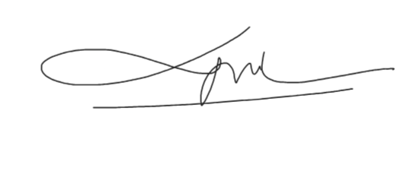

References
- Kharbach, M. (2026). AI Use Policy Templates for Higher Education. CC BY-NC-SA 4.0.
- ISTQB Foundation Level Syllabus (latest version).
- Hardman, P. (2025). A Post-AI Learning Taxonomy.
- Fuster Rabella, M. (2025). OECD Education Working Paper No. 338.
- Perkins, M., Roe, J., & Furze, L. (2025). AI Assessment Scale.
- Anthropic (2025). Building reliable AI test agents — engineering blog.
- DeepEval & Promptfoo documentation — testing frameworks for LLM systems.

